Task 3

-rank(close-ts_product(close,5)^0.2)

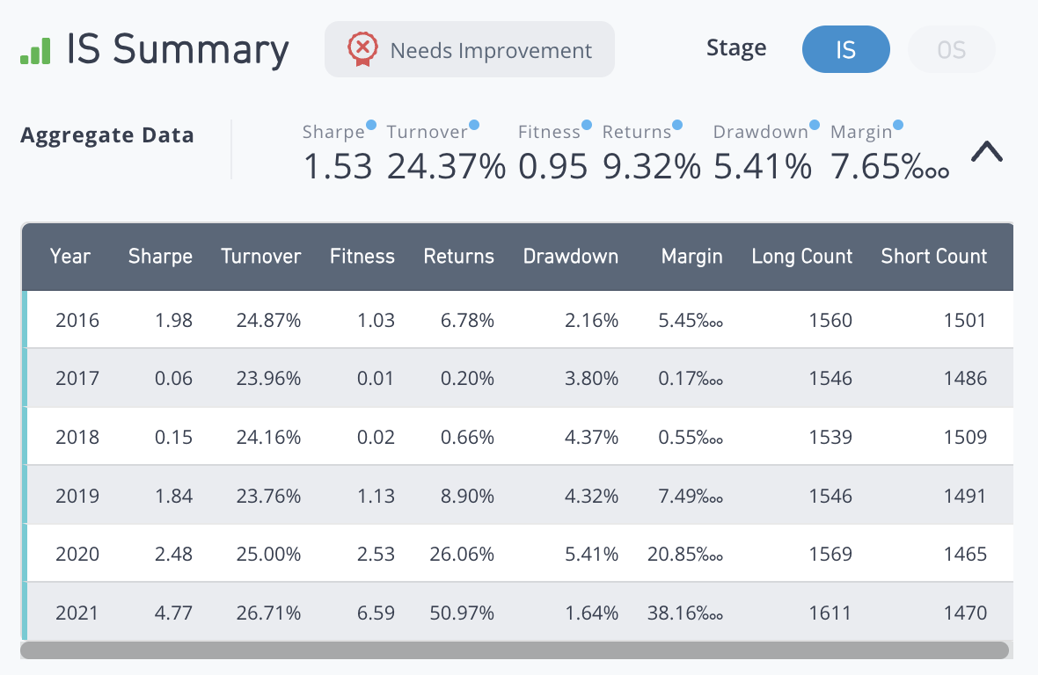

rank(ts_returns(correlation_last_30_days_spy, 10))

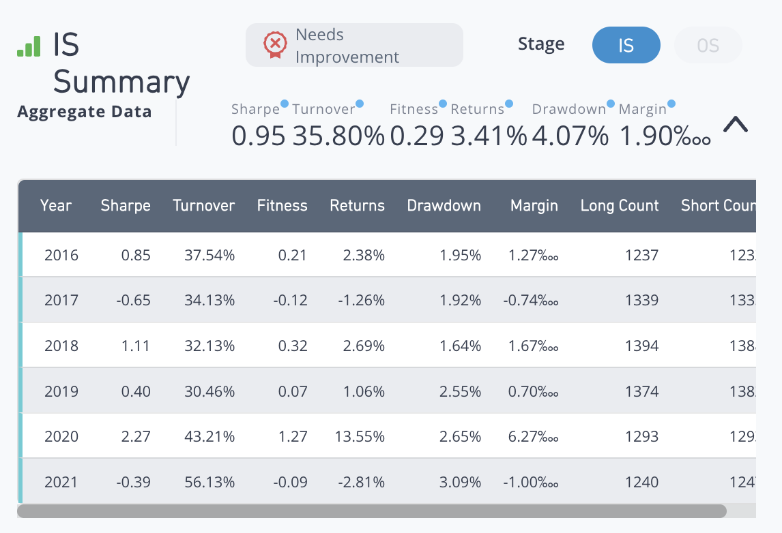

-rank(quantile(ts_weighted_delay(open)))

